  - Friends of Ferncumbe
  - Activity Summary April 2017 to August 2018
Overview of the Friends of Ferncumbe Committee, funds raised and investments committed.

Friends of Ferncumbe
  - Activity Summary

Overview
The Friends of Ferncumbe are a charity working closely alongside The Ferncumbe CofE Primary School. We are lead and run by a Committee made up of parent volunteers and the school’s Headteacher, Sally Morris. As a Charity, we ensure that we comply with all guidelines and processes set out by the Charities Commission.
Together, our primary purpose is to support the school, helping to enhance the daily school experience and advance the education of the pupils currently in attendance.
We do this by organizing a number of fundraising activities throughout the year and then working closely with the school and pupils to assess where this money could be put to best use and most benefit.
This report provides a full review of the activities we organized in the Financial Year from April 2017 to August 2018, what funds were raised and how the money was spent.

Fundraising Goal
This year, in addition to our regular fundraising commitments, our key goal was to raise money to support the school in purchasing new IT equipment. Many of the existing Netbooks and iPads in school were old, worn out and starting to break. As technology plays such an important part of the world our children are growing up in and will go on to work in, we believed this was an excellent cause to support.

Fundraising Activities
To achieve our fundraising goals, the Friends of Ferncumbe organise a whole calendar of events and activities for pupils, familes and friends. Between April 2017 and August 2018, we decided to stretch ourselves a little further, organising all of our regular annual events and activities, plus 2 new ones. We were delighted to bring back the Parents’ Quiz Night after a number of years, and we introduced a brand new event, the Spring Ball. Both were a huge success and a lot of fun was had by all.
Our full list of activities and events included:
- School BBQ
- Movie Night
- Christmas Cards
- Calendars
- DVDs of the School Christmas Performances
- Quiz Night for parents – NEW
- School Disco
- Easter Bingo
- Spring Ball – NEW
- Summer Fete
- Tea and Coffees at Farmer’s Markets and Sports Day
In addition to this, we have received very generous support from companies, both local, national and international, through donations, match-funding and sponsorships.
As a result, we raised just over £12,000 after expenses.
As ever, we received fantastic support from all of the pupils, families, teaching staff, local businesses and community at Ferncumbe. We couldn’t run any of these activities or raise this level of funds without you. We’re very proud of what we have all achieved together and what’s more, everyone seemed to have an awful lot of fun in the process!

Fun at The Spring Ball:
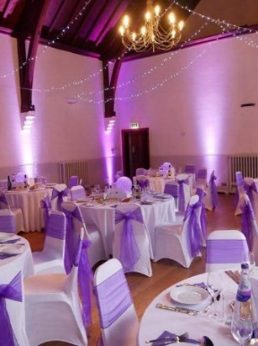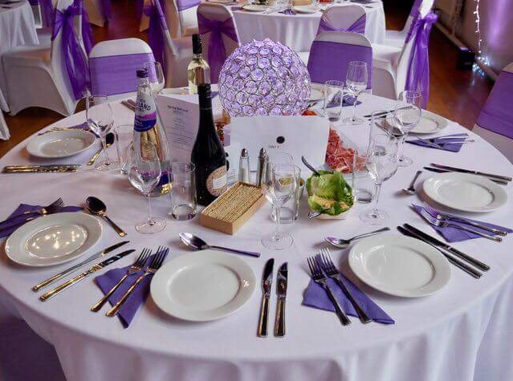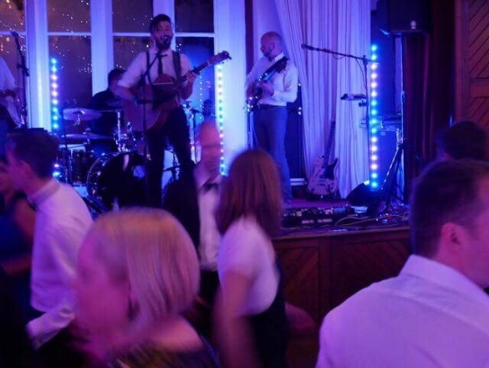

Around the World at The Summer Fete
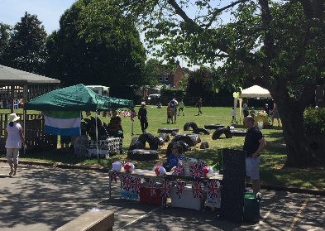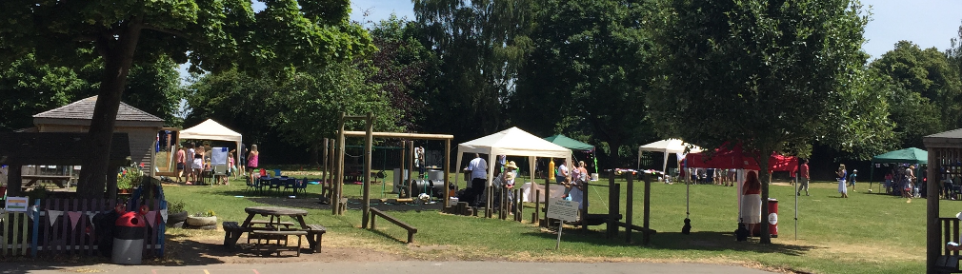
How Have The Funds Been Used?
Each year, we take care to work closely with the school and the pupils to ensure that the money we raise is used where it could be of most benefit. In line with our key IT-based fundraising goal this year, we were thrilled to be able to co-fund 20 new Netbooks. These are already in school and making a huge difference. We have also funded 9 new iPads and these are on their way.
As well as IT, we have also donated money to Forest School. This was used to replace old and worn out equipment as well as investing in new items to enrich the experience for children across the school years. This ranged from new waterproofs, some replacement storm kettles, den-building materials, better storage facilities and other key pieces of kit.

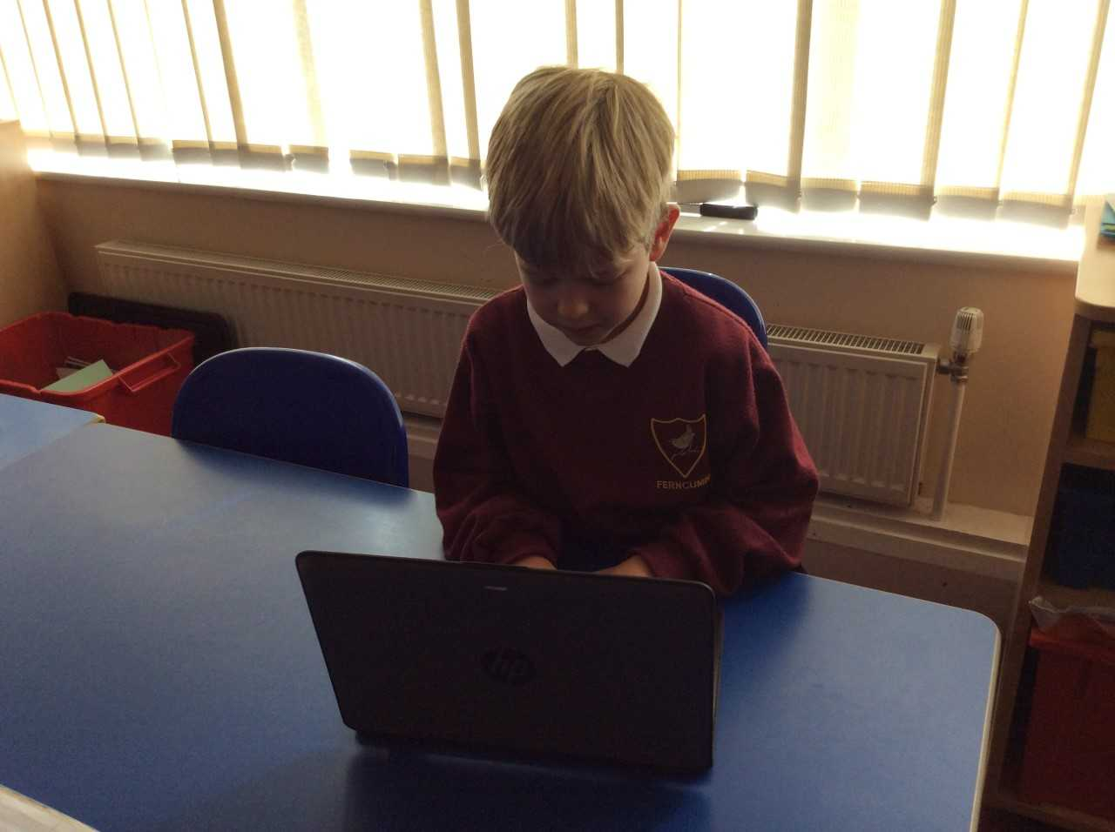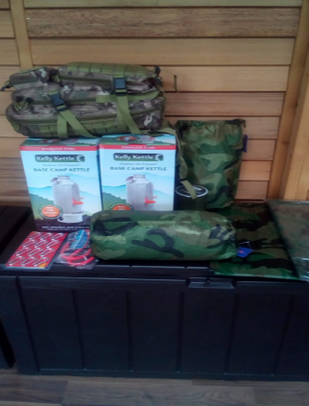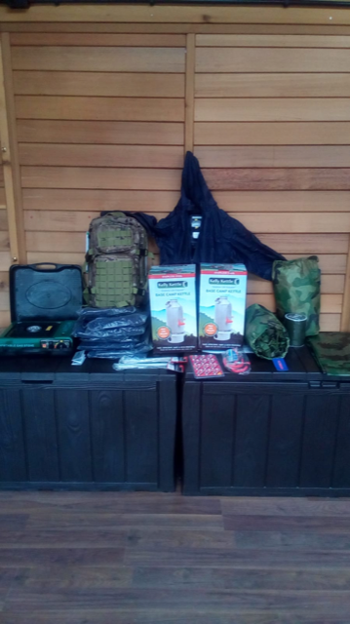

We have also continued to allocate some of our Friends of Ferncumbe funds to our regular donation causes, such as supporting KS2 enrichment activities, coaches for Christmas pantomime trips and Year 6 Leavers Party, amongst other things. All in all this year, we have allocated Friends of Ferncumbe funds towards:
- New Netbooks and iPads
- Forest School
- Log Traverse and Repairs to Wooden Train in Playground
- New PA system for school and Friends of Ferncumbe events
- KS2 Enrichment Activities
- Coaches for Christmas Pantomime Trip
- Christmas Presents for each pupil
- New Bark for the Playground
- Contribution towards Year 6 Leavers Party
The items listed above account for around £8,000 of funds already spent and a further £4,000 of funding committed. That’s around £12,000 of benefit for our school and pupils.
‘Thank You’
We are absolutely thrilled with how this year has gone and how much we have been able to support everyday school life. But we couldn’t have achieved any of this, without a huge amount of help and support.
We would like to extend special thanks to:
- Our Friends of Ferncumbe Committee Members for all of their time, support and sense of fun over the past year.
- The volunteers who have helped us organise and run all of the activities and events
- All of the pupils, families, teachers and friends who have come along to each and all of our events to help us achieve our fantastic fundraising success.
- All of those parents who have approached their employers for match-funding or charitable donations. It really does make a massive difference.
- The incredibly generous local companies who have given donations, either financial or prizes for various raffles and auctions.

September 2018-August 2019
We look forward to welcoming new Committee Members in to the Friends of Ferncumbe and having another successful year in 2018/19. The detail of the year ahead will start to be planned out after the new Committee is voted in at our AGM on Wednesday October 3rd.

Getting Involved
Our Committee is here to get involved, help co-ordinate some of the activities where they are able to, help agree what our key fundraising goals are and where the money we raise could be of most benefit to school and pupils. We welcome all new members, whether you can only help a little or a lot. If you are interested in becoming a Friends of Ferncumbe Committee Member, please come along to our AGM on 3rd October 2018, where our new Committee will be formed.
Even if you don’t think being on the Committee is for you, you can still help out. Whether you would like to help out co-ordinating one of the acitivites, have ideas of your own for a new activity you would like to run to raise money for the Friends of Ferncumbe or would just like to help out at one or more of our events, all help is very welcome. Please email us at thefriendsofferncumbe@gmail.com.

