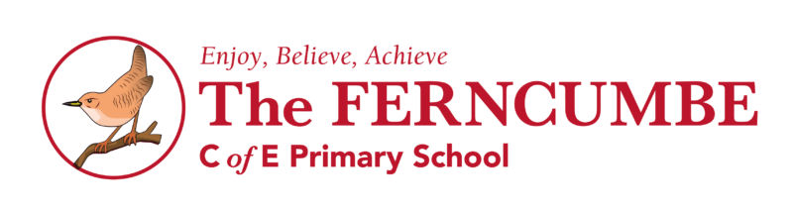
Reading
Year 6
Age Related Expectations
Statement
Use knowledge of morphology and etymology to read aloud and understand new words
Make comparisons within and across books
Identify and discuss themes and conventions across a wide range of writing
Explain the meaning of words in context
Summarise ideas drawn from more than one paragraphs, identifying key details
Predict future events from details stated and implied
Identify how language, structure and presentation contribute to meaning
Discuss how authors use language, including figurative language, to affect the reader
Retrieve and record information
Provide reasoned justifications for views
Make inferences from the text explaining and justifying these with evidence

